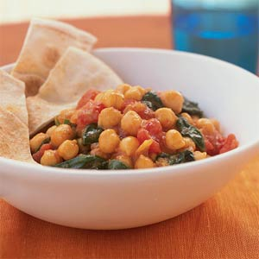
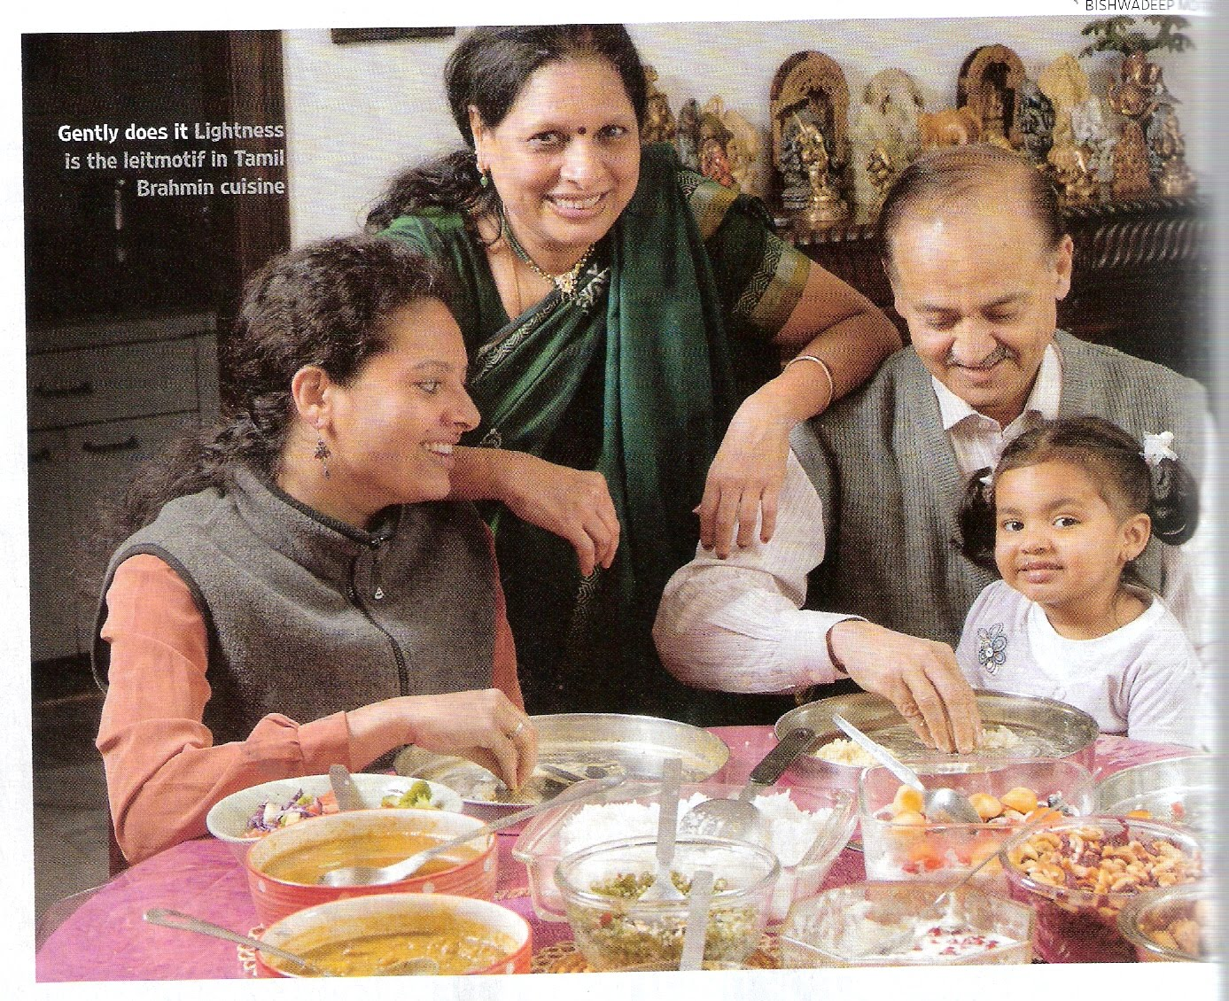

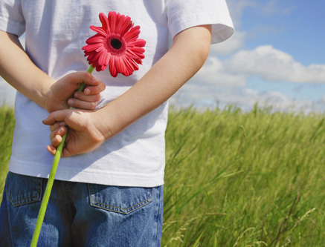
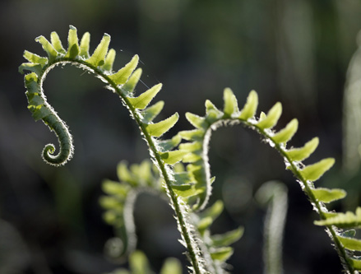

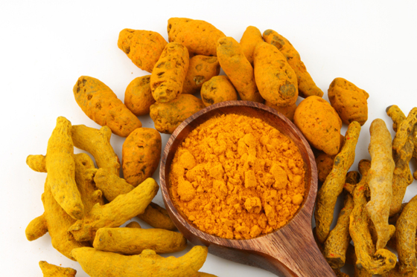
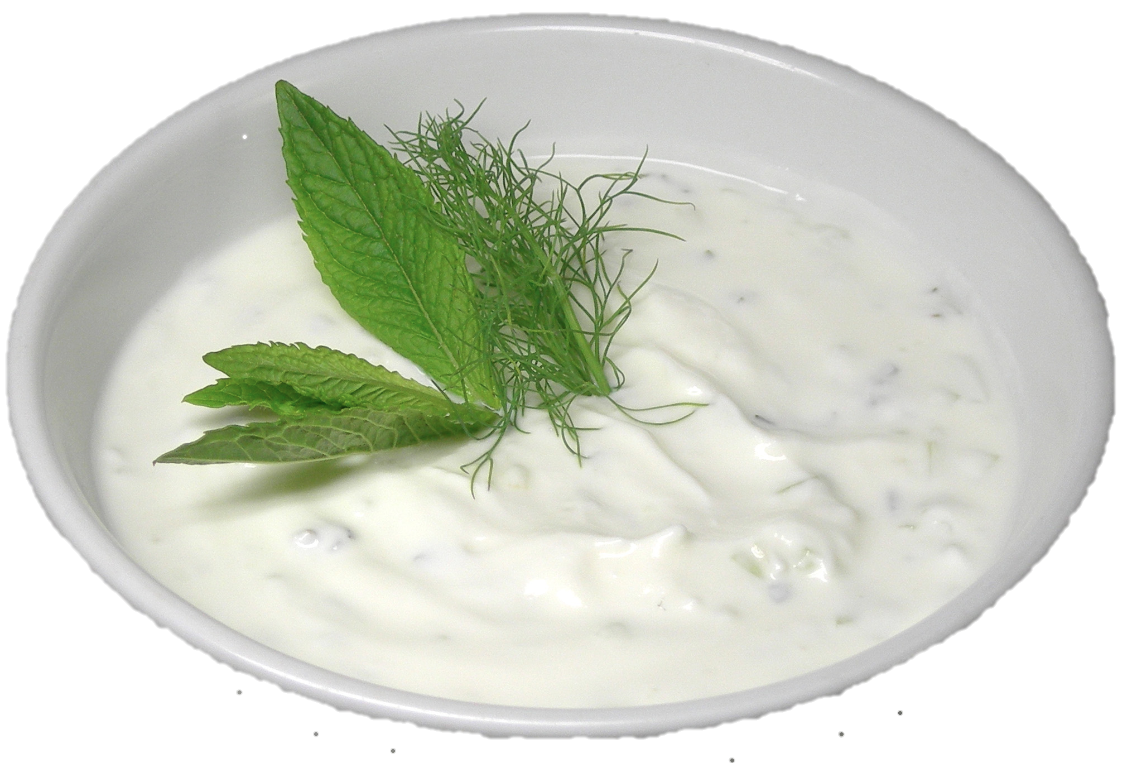

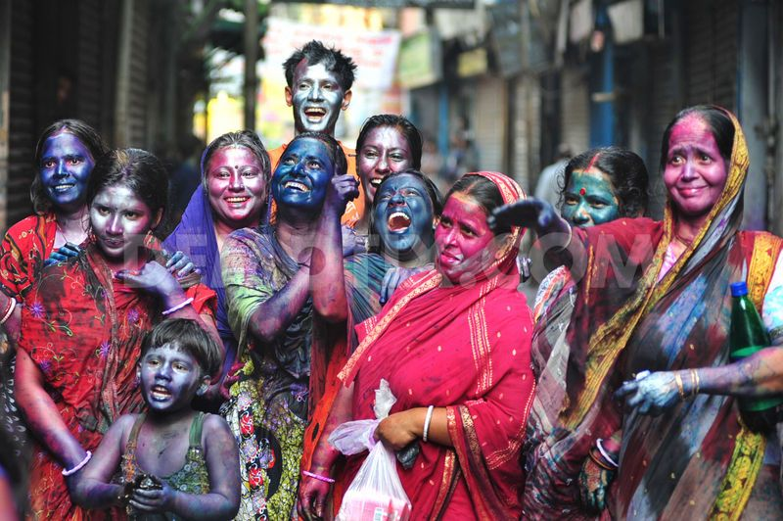

These health care providers can test if you or a loved one is at risk of developing diabetes:
Indian American Medical Association of Greater Washington DC

Indian Medical Association of America

Virginia Association of American Physicians of Indian Origin (VAAPI)

To find culturally aware doctors visit:
http://www.aapiusa.org
for a list of providers near you!
http://www.myrecipes.com/recipe/chickpea-spinach-curry-10000000354461/
This is a healthy recipe that can replace curries that contribute to diabetes.
Ingredients: 1 cup chopped onion, 1 ½ tbsp. ground ginger, 1 tsp olive oil, 1 ½ tsp sugar, 1 ½ tsp red curry powder, 1 (19 oz.) can of chickpeas, rinsed and drained, 1 (14.5 oz) can diced tomatoes, undrained, 4 cups fresh spinach, ½ cup water, ¼ tsp salt
Directions:
Place onion and ginger in food processor and pulse until minced. Heat oil in large skillet over medium-high heat. Add onion mixture sugar and curry to pan; sauté 3 minutes. Add chickpeas and tomatoes; simmer 2 minutes. Stir in spinach, water and salt; cook 1 minute or until spinach wilts.

Diabetes-Friendly Curry
  - By: Cassidy Pont

Asian Indians Combat Diabetes
Diabetes affects how the body uses glucose, which is an important energy source for cells that make up the body’s muscle and tissues, and also powers the brain. When a person has diabetes, they have too much glucose in the blood, which can lead to other serious health problems, such as coronary heart disease and cardiovascular disease. Asian Indians have the highest number of cases of diabetes in the world. Diet and exercise can help ward off diabetes.

What is Diabetes? मधुमेह क्या है? (Madhumēha kyā hai?)

Modify your lifestyle to fight diabetes!
Keep your body balanced with the following tips:
- Instead of adding salt or sugar to curries, add herbs and spices, such as turmeric, ginger, mint and garlic, which provide great flavor and health benefits
- Be mindful of the amount of rice you are consuming in a meal (should be about ¼ of your plate)
- Use low-fat or non-fat yogurts as a side dish and in cooking
- Be active with your family! Take part in Holi by running around throwing paint on family members and friends, go on family walks, play in the park, or dance to Hindi music!
- Perform yoga with family and friends
http://www.healthpowerforminorities.com/HealthChannelDetails.aspx?id=100

